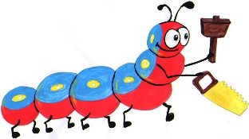

Lyng Primary School Knowledge Organiser

Design Technology



Memory Cushion – links to transition (PSHE)

Year 6

Topic: DT

Summer

|  |  |
| --- | --- |
| What Goldilocks and Step On words will I use? | |
| **Spelling** | **Defintion** |
| Fabric | A natural or man-made woven, or knitted material that is made from plant fibres, animal fur or synthetic material. |
| Fastening | A closing and opening detail on clothing such as buttons, zips, and press-studs. |
| Properties | The way in which we describe materials for their appearance, strengths and weakness. |
| Running-stitch | A simple style of sewing in a atsright line with no overlapping. |
| Seam | A line along the two edges of cloth that are joined or sewn together, |
| sew | To join or fasten by stitchewith htread and a needle. |
| target audience | A particulary group of people who the product aimed at |
| target customer | A particular type of person who the product is aimed at. |



Summer Term -

**Textiles**

**Design Brief for pupils:**To help you remember and cherish your time at Lyng Primary School, produce a memory cushion using their old uniform.

**Purpose:** Produce a cushion using their old primary uniform as a memory of their time at Lyng

**Audience:** Year 6 children leaving primary

|  |
| --- |
| Skills and techniques |
| * Create innovative designs that improve upon existing products. * Use the qualities of materials to create suitable visual and tactile effects in the decoration of textiles. * Experiment with different sewing techniques e.g. back stitch, cross stitch and running stitch * Cut materials with precision and refine the finish with appropriate tools * Join textiles with appropriate stitching. * Ensure products have a high quality finish, using art skills where appropriate. * Evaluate whether your design meets the criteria of the design brief. |

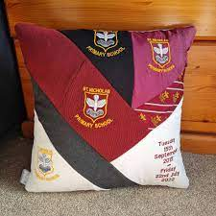

**Different sewing techniques.**

Watch these videos to help you learn how to sew using different stitching techniques. This will help use closing our seams on our toys.

Running stitch: <https://www.youtube.com/watch?v=i1-B01FB56s>

Back stitch: <https://www.youtube.com/watch?v=sjHm8CL9WDA>

Ladder stitch (invisible stitch): <https://www.youtube.com/watch?v=c2B_fgEGMlM>

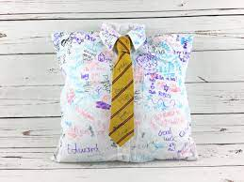

**Agreed outcome:**

Memory cushion made from old primary school uniform